FAQ Online Bill Pay
I have not registered an online account, but I am currently on auto draft.
Your account was transferred to the new system by AMUD and will need to be deactivated by AMUD prior to setting up your online registration. Call the office at 817-326-4720 to deactivate your AMUD auto draft then continue with how to create account access and benefit instructions.
How do I create account to gain full access and benefits to this new system?
- Access the Customer Payment Portal through the AMUD website at www.amud.com.
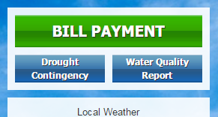
  - Click on the green Bill Payment button in the upper left hand corner.
  - Click on the red Pay Your Bill button. This will direct you to the Customer Portal.
- Create an account by going to Register Now.
  - Enter New Account Information and click on Enroll button.
  - Confirm your information and click on Login to Customer portal button.
  - Add Account, enter your AMUD Account Number (include all dashes).
  - Agree to terms and conditions and click on Add Account button.
- Set up your Auto Draft, scheduling and notification settings

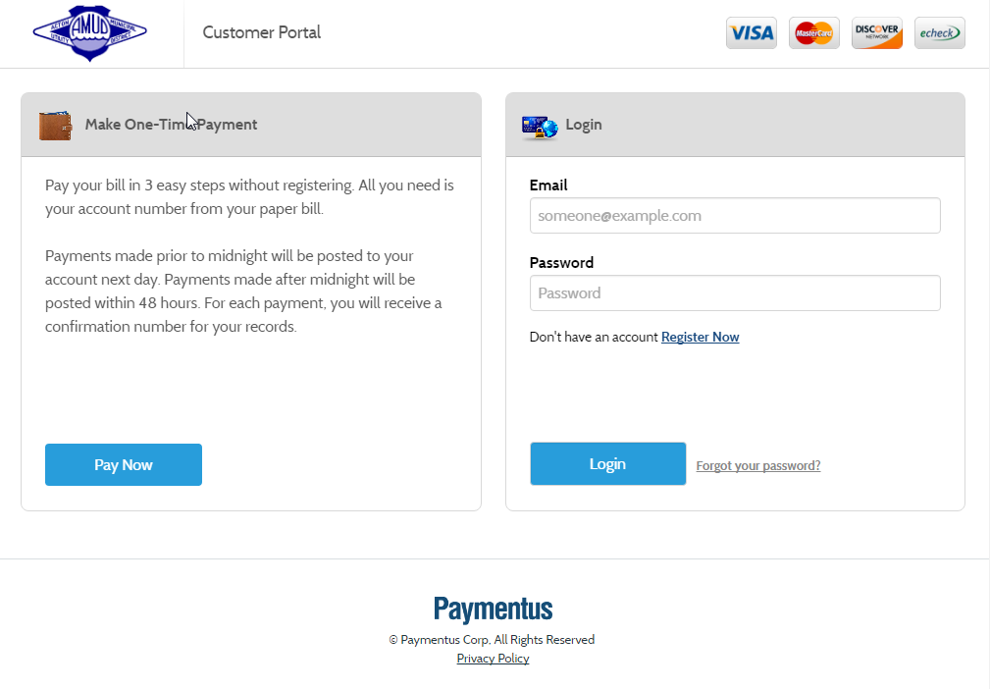

Credit card information, check routing information, scheduling one time payments and/or setting up recurring draft payments and creating your own account alerts can all be done at your convenience online.
Remember to update your payment options, i.e. expiration dates, account number changes, etc.

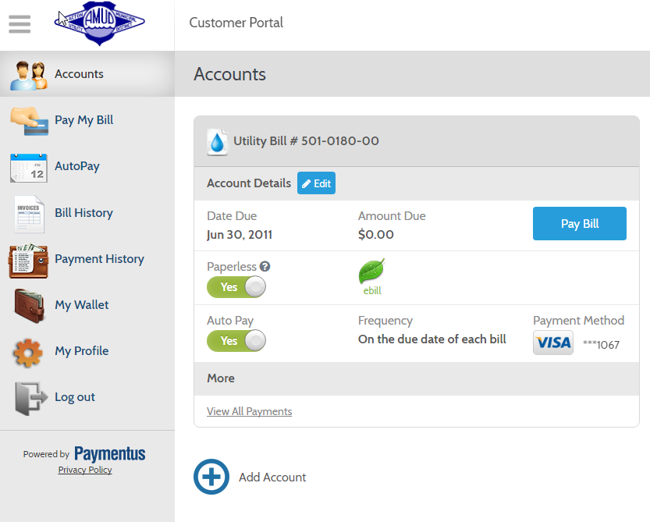
Why can’t I see ‘My Wallet’ or ‘Auto Pay’ icons?
- Click on in upper left corner of webpage to toggle menu on/off.
How do I change Payment Method Information?
- Click on “My Wallet”
- Click “Edit” to make changes to existing payment method
- Click “Add Payment Method” to add a new payment method
- Click on “Accounts” to verify current payment method and to turn on/off Auto pay.
How do I set up Auto Pay Notifications?
- Click on “Auto pay”
- Click on “Edit”, to right of schedule
- Frequency defaults to ‘Due date of each bill’ and cannot be changed
- Do NOT fill in ‘End Date’ unless you want to stop the Auto Draft after a certain date.
- Click on “Receive email notification” OR “Receive SMS notification”
- Choose the number of days in advance of a scheduled payment that you want to receive notice.
- Make sure to click ‘CONFIRM’ to complete setting changes.
How do I Add additional accounts to User Login?
- Click on “Accounts”
- Click on ‘Add Account’
  - Click on “I agree to Terms & Conditions”, then click “Add Account”
  - Click on “Back to Accounts” button
- Both accounts should now appear on screen. You can add up to 25 accounts.

